# Homework 5 – Active Directory and Group Policy Objects

**Daniel Hutchins – CIS 483-75**

* (**Task 1**) Show in a screenshot that the three domain users (sqluser1, sqluser2, sqluser3) are created in **SQLUsers** OU. Also show in a screenshot that **sqlgroup** is created in the **Groups** OU.

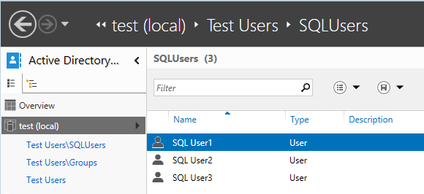

**SQL Users 1-3 in the SQLUsers OU.**

**sqlgroup in the Groups OU.**

* (**Task 2**) Go to sqluser1 properties and show in a screenshot that sqluser1 is a member of **Domain Admins** and **sqlgroup**.

**SQL User1 “Member of” Groups.**

* (**Task 3**) Run the following query on SQL Server and show in a screenshot that you indeed logged-on with sqluser1.

**Current user on SQL Server.**

* (**Task 4**) Logon to SQL Server. Create a login “**Cardinal1**”. Select **SQL Server authentication**. Enter the password “1234567”, and show in a screenshot that the login cannot be created. Explain why?

**Failed login creation, this is due to the password not having enough complexity. (Simple structure as 1234567 does not have varying characters).**

* (**Task 5**) Create a login “**Cardinal2**”. Select **SQL Server authentication**. Enter the password “1234567”, and show in a screenshot that the login is created. Explain why this was possible. Explain also the relationship between the GPO and the SQL Server password policy.

**Login for Cardinal2 created. This is because the password meets the minimum length and is not being checked for complexity. In terms of GPO and SQL Server policy, the default SQL policy of password complexity is overruled by the GPO’s password requirements. The checkbox for “Enforce password policy” is checked on the SQL Server side which verifies with the GPO on the AD.**

* (**Task 6**) Create a new AD account using the command **New-ADUser** explained on pp 12-13. Show in a screenshot that the account is indeed created (example below). Also, attach a screenshot that displays the PowerShell execution.

**Daniel Hutchins user created through PowerShell.**

**Execution of the PowerShell command to create the user “Daniel Hutchins”.**